Instruction to run the project.

**Prerequisities**

* Docker Desktop
* .NET 6 SDK
* DBeaver (Any tool for browse the data in docker containerized Postgre SQL DB)

**Steps for Run the project**

* Navigate to the project folder from command line(CMD) and run the following command

docker-compose up -d

* Run the API Project. It will automatically seeds necessary data.

**Special Notes for changes done**

* Introduced new table “Order” in order to keep order data

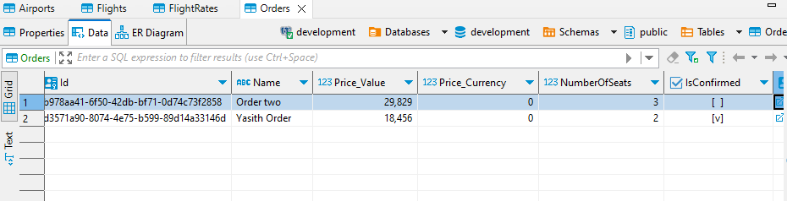

* Modified Entity Codes and Run a db Migration
* Added Sperate OrderController for manage Order related Apis. Ex: Create Order, Confirm Order
* Added required fluent validators.
* Followed the given instructions to complete the assessment.